Veterans Appreciation Concert 2018
We support the Seymour / Oxford Food Bank
American Legion Post 10 and VFW Post 12084
Presented By:
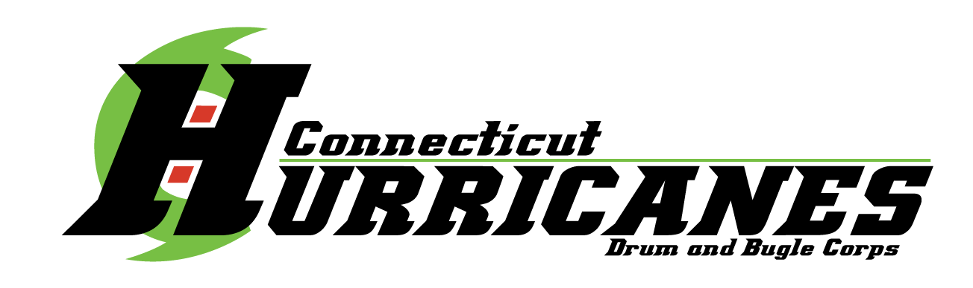
Saturday April 28, 2018 – @ 6:30 PM
Seymour Middle School Auditorium, Seymour, CT
Program Ad Book Form
Contact Person: Tom Gabianelli at tgabs@att.net or (203) 231-2682
AD Sizes Price (circle one)
Show Sponsor $1,000.00 -
Back Cover $200.00 -
Inside Cover $150.00 -
Full Page $100.00
Half Page $ 50.00
Third of a Page $ 25.00
Ad sold to:
Name/Company: ______________________________________
____________________________________________________
Address: ____________________________________________
____________________________________________________
Email: ______________________________________________
Telephone No.: ______________________________________ Make checks payable to CT Hurricanes Drum & Bugle Corps
Affix AD Artwork, Business Card or desired text:
Send checks and artwork to: George Bashura, 58 Jupiter Drive, Seymour, CT 06483

